Dear Sirs and Mesdames:

**Re:**

**Date:**

The parties have agreed to participate in a **full day** mediation session (“mediation”) to be conducted by me on April xx, xx using Zoom commencing at 10:00 a.m.

Through their counsel, if represented, the parties and their law firms agree that:

1. All statements made and documents produced during the mediation and not otherwise

discoverable shall not be subject to disclosure through discovery or any other process and shall be confidential. Such statements and documents shall not be admissible into evidence for any purpose, including impeaching credibility or to establish the meaning and/or validity of any settlement or alleged settlement arising from the mediation.

1. More particularly, my notes, records, and recollections shall be confidential and protected

from disclosure for all purposes in accordance with paragraph 1.

1. I am being retained for the sole purpose of facilitating settlement discussions and not for the purpose of giving legal advice.
2. The Parties will exchange and provide me with copies of mediation briefs generally outlining

the parties’ differences and interests no later than **seven days prior to the mediation.**

1. The Parties agree to be jointly and severally liable to pay my fees which will be xx per full day mediation and xx per hour for additional hour plus HST. The Parties agree that if the mediation is cancelled 30 days or less prior to the mediation date, a cancellation fee of xx plus disbursements and HST is applicable.
2. The Parties agree to be jointly and severally liable to pay the court reporter’s fees and any

associated disbursements.

1. While all parties intend to continue with the Mediation until a settlement agreement is

reached, it is understood that any party may withdraw from Mediation at any time.

1. The parties will either themselves or through their representatives have full, unqualified

authority to settle and understand that the Mediation may result in a settlement agreement that contains legally binding obligations that are enforceable in a court of law.

1. Each party may sign a separate copy of this Agreement and the counterparts, when signed

and delivered to me shall together constitute evidence of the intention of each and every party to be bound by the Agreement.

1. The parties agree that I may dispose of all documents relating to this matter 60 days

following the completion of the mediation. This period may be extended at the request of any party.

1. If the above is acceptable please sign, date and return a copy of this letter to me.

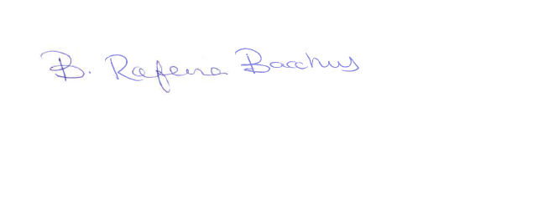Yours Truly,

Date:____________________ _________________________________

Date:____________________ ___________________________________